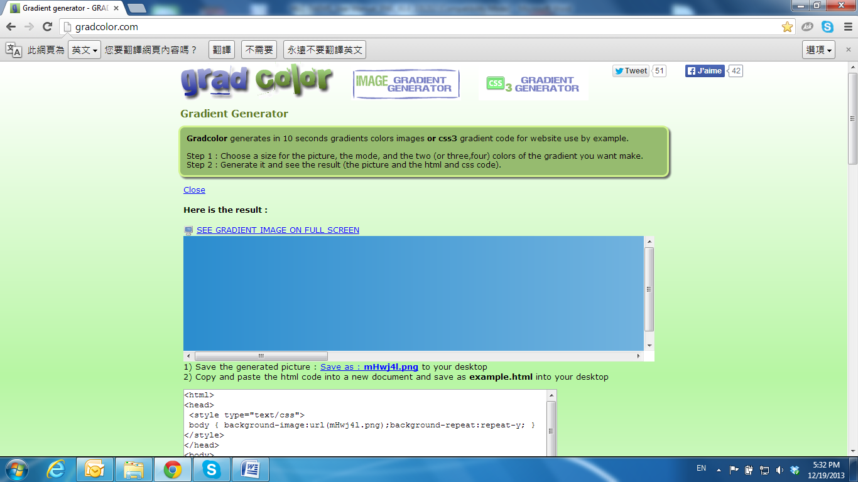

Micro SD Card Compatibility

The following are the recommended Micro SD Cards:

|  |  |
| --- | --- |
| Transcend | SDHC class4 16GB SDHC class4 32GB SD class4 16GB SD class4 32GB SDHC class6 4GB SDHC class6 8GB SDHC class6 16GB SD class6 4GB SD class6 8GB SD class6 16GB SDHC class10 4GB SDHC class10 8GB SDHC class10 16GB |
| SanDisk | SDHC class4 4GB SDHC class4 8GB SDHC class4 16GB SDHC class4 32GB |